ADMINISTRACION DE REDES

Alumno

BARRAZA LUGO FRANCISCO ANTONIO

Tema

Practica 1.2.1.7

Maestro

LUIS ERNESTO LIZÁRRAGA BOLAÑOS

Horario

07:00-08:00 am



Packet Tracer - Compare 2960 and 3560

1. Topology

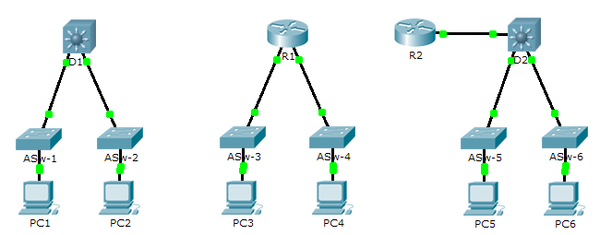

1. Objective

Part 1: Compare Layer 2 and Layer 3 Switches

Part 2: Compare a Layer 3 Switch and a Router

1. Background

In this activity, you will use various commands to examine three different switching topologies and compare the similarities and differences between the 2960 and 3560 switches. You will also compare the routing table of a 1941 router with a 3560 switch.

1. Compare Layer 2 and Layer 3 Switches
   * 1. Examine the physical aspects of **D1** and **ASw-1**.

Each individual switch has how many physical interfaces? Tienen 26

How many Fast Ethernet and Gigabit Ethernet interfaces does each switch have?

24 Fast Ethernet y 2 Gigabit Ethernet

List the transmission speed of the Fast Ethernet and Gigabit Ethernet interfaces on each switch.

Las interfaces Fast Ethernet 10 / 100mb / s, y las interfaces Gigabit Ethernet hasta 1000mb / s.

Are either of the two switches modular in design? No ya que no está separado de esa forma de diseño

* + 1. The interface of a 3560 switch can be configured as a Layer 3 interface by entering the **no switchport** command in interface configuration mode. This allows technicians to assign an IP address and subnet mask to the interface the same way it is configured on a router’s interface.

What is the difference between a Layer 2 switch and a Layer 3 switch?

La capa 2 toma decisiones de reenvío basadas en direcciones MAC en cambio las interfaces en los switches de Capa 3 se pueden configurar con direcciones IP. Estos también se pueden configurar con protocolos de enrutamiento como un router.

What is the difference between a switch’s physical interface and the VLAN interface?

La interfaz física de un conmutador se utiliza para conectar físicamente los dispositivos .Y en cambio se usa una virtual como una interfaz vlan para configurar el conmutador con una dirección IP para que se pueda administrar de forma remota.

On which layers do 2960 and 3560 switches operate?

El 2960 son de capa 2 y el 3560 opera en las capas 2 y 3 ya que se le pueden asignar ip para ser administrada.

Issue the **show run** command to examine the configurations of the **D1** and **ASw-1** switches. Do you notice any differences between them?

Las interfaces Gigabit Ethernet de D1 están configuradas con el comando no switchport y muestran una dirección IP y una máscara

Display the routing table on both switches using the **show ip route** command. Why do you think the command does not work on **ASW-1**, but works on **D1**?

Funciona en D1 porque funciona en las capas 2 y 3 ya que le permite tener una ip configurada, lo que le permite funcionar como un router

1. Compare a Layer 3 Switch and a Router
   * 1. Up until recently, switches and routers have been separate and distinct devices. The term switch was set aside for hardware devices that function at Layer 2. Routers, on the other hand, are devices that make forwarding decisions based on Layer 3 information. They use routing protocols to share routing information and to communicate with other routers. Layer 3 switches, such as the 3560, can be configured to forward Layer 3 packets. Entering the **ip routing** command in global configuration mode allows Layer 3 switches to be configured with routing protocols, thereby possessing some of the same capabilities as a router. Although similar in some forms, switches are different than in many other aspects.

Open the Physical tab on D1 and R1. Do you notice any similarities between the two? Do you notice any differences between the two?

Ambos tienen un puerto de consola y dos interfaces Gigabit Ethernet. R1 es modular y puede agregar varias interfaces, mientras que D1 solo tiene interfaces fijas. R1 tiene interfaces seriales y asíncronas, mientras que D1 solo tiene interfaces Ethernet. D1 solo puede usar cables de cobre, mientras que R1 puede usar varios tipos de conexión.Issue the **show run** command and examine the configurations of R1 and D1. What differences do you see between the two?

R1

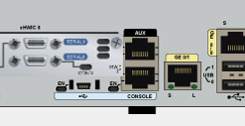

D1

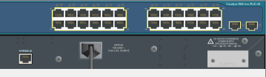

R1 es modular y puede agregar más interfaces, mientras que D1 solo tiene interfaces fijas, Los dos tienen Puerto de consola y dos interfaces gigabit Ethernet

Which command allows D1 to configure an IP address on one of its physical interfaces?

El comando no switchport

Use the **show ip route** command on both devices. Do you see any similarities or differences between the two tables?

Solo cambia que R1 tiene una interfaz local pero son similares

Now, analyze the routing table of R2 and D2. What is evident now that was not in the configuration of R1 and D1?

tienen configurado EIGRP

* + 1. Verify that each topology has full connectivity by completing the following tests:
* Ping from **PC1** to **PC2**

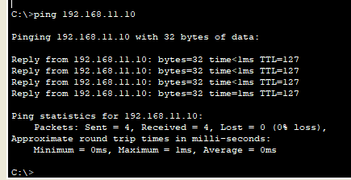

* Ping from **PC3** to **PC4**

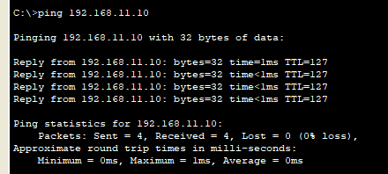

* Ping from **PC5** to **PC6**

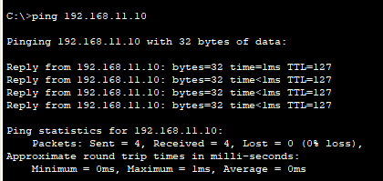

In all three examples, each PC is on a different network. Which device is used to provide communication between networks?

Enrutador o switch multicapa

Why were we able to ping across networks without there being a router?

Gracias al switch multicapa que le podemos configurar una dirección ip con el comando no switchport y así hacer un enrutamiento

1. Suggested Scoring Rubric

|  |  |  |  |
| --- | --- | --- | --- |
| Activity Section | Question Location | Possible Points | Earned Points |
| Part 1: Compare Layer 2 and Layer 3 Switches | a | 20 |  |
| b | 40 |  |
| **Part 1 Total** | | **60** |  |
| Part 2: Compare a Layer 3 Switch and a Router | a | 30 |  |
| b | 10 |  |
| **Part 2 Total** | | **40** |  |
| **Total Score** | | **100** |  |